**KNOWLEDGE AS MEDICINE:**

**Elevate Your Health IQ!**

**NAME OF LOCAL MUSEUM/LIBRARY** is teaming up with the federal Institute of Museum and Library Services (IMLS) to offer health learning opportunities for our community.

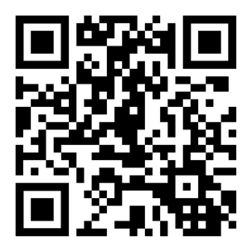Trainings at **NAME OF LOCAL MUSEUM/LIBRARY** are being offered on translating complex health terms, confidently communicating with your health care providers, and identifying health resources online for accuracy and reliability.

Learn more at [**Local website**] and find more health educational resources, as well as financial and digital educational resources, at [**www.InformationLiteracy.gov.**](http://www.InformationLiteracy.gov.)

If you would like to get involved or sign up, please **INSERT WAY TO CONTACT HOST**.