**KNOWLEDGE AS WEALTH:**

**Elevate Your Financial IQ!**

**NAME OF LOCAL MUSEUM/LIBRARY** is teaming up with the federal Institute of Museum and Library Services (IMLS) to offer financial learning opportunities for our community.

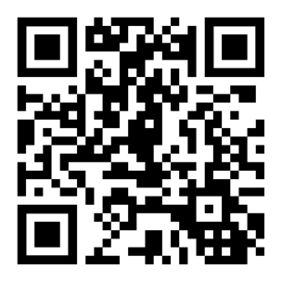Trainings at **NAME OF LOCAL MUSEUM/LIBRARY** are being offered on opening a bank account, managing money with confidence, recognizing scams, and filing taxes!

Learn more at [**Local website**] and find more financial educational resources, as well as health and digital educational resources, at [**www.InformationLiteracy.gov.**](http://www.InformationLiteracy.gov.)

If you would like to get involved or sign up, please **INSERT WAY TO CONTACT HOST**.